Gradle intro

**MAKE A GRADLE PROJECT FROM THE CMD**

1.we do a gradle init

THE above 4 folders will be created at your machine

1.You will have to select the typeof project which we select as application then we select language as java

**DSL(DOMAIN SPECIFIC LANGUAGE)

In gradle we can write our script either in groovy or kotlin

Test framework

You can give the project and package name as above

The above project is created.

**Build.gradle** is the build script file where we specify all the build related stuf.

**.gradle** stores all the downloaded dependencies

**BUILDING A GRADLE PROJECT**

We can build a gradle project by simply going into that folder and then running build command

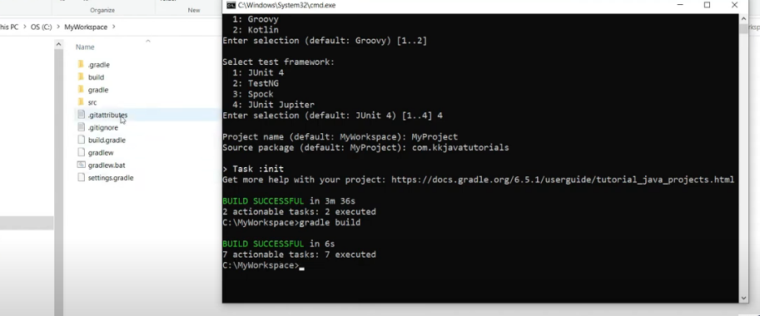

Now go to build forder

You get the jar file

.class files a also present in the build

Two ways of giving a build command

|  |
| --- |
| **Gradle build** |
| **Gradlew.bat build /gradlew.bat clean** |

**RUNNING THE ROJECT**

Gradle run

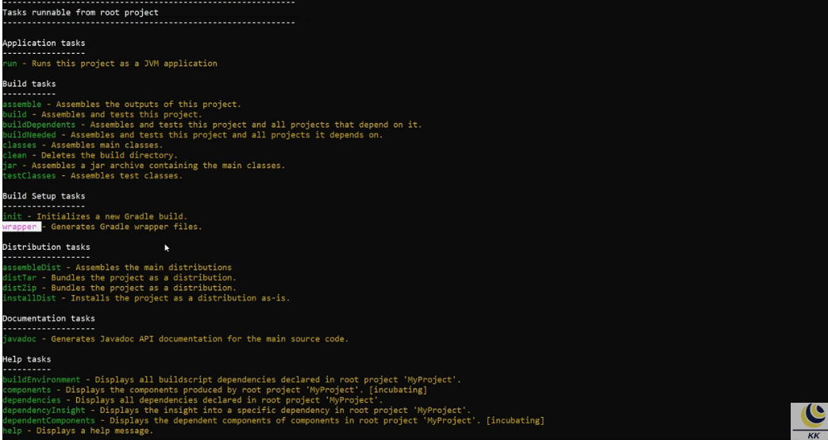

**IMPORT GRADLE PROJECT IN ECLIPSE**

Simply import as gradle project

Then you can install the gradle plugin

And setup the gradle location

**NEW JAVA PROJECT IN ECLIPSE**

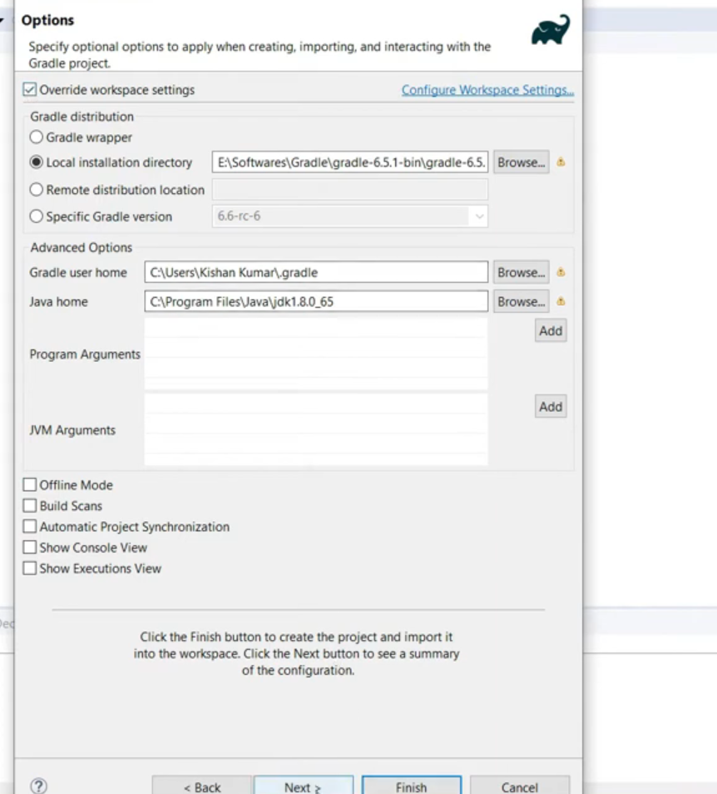**\**

**WHEN WE MAKE A NEW PROJECT WHERE DO WE SPECIFY THE DEPENDENCIES?**we specify in build.gradle file

It is written in groovy language

Now in order to add some dependency of your choie what you can do is copy from repository

Add in dependencies section

After this do gradle ->refresh gradle

**PUBLISHING YOUR GRADLE BUILD TO THE GRADLE HUB**

**GRADLE SCRIPT**

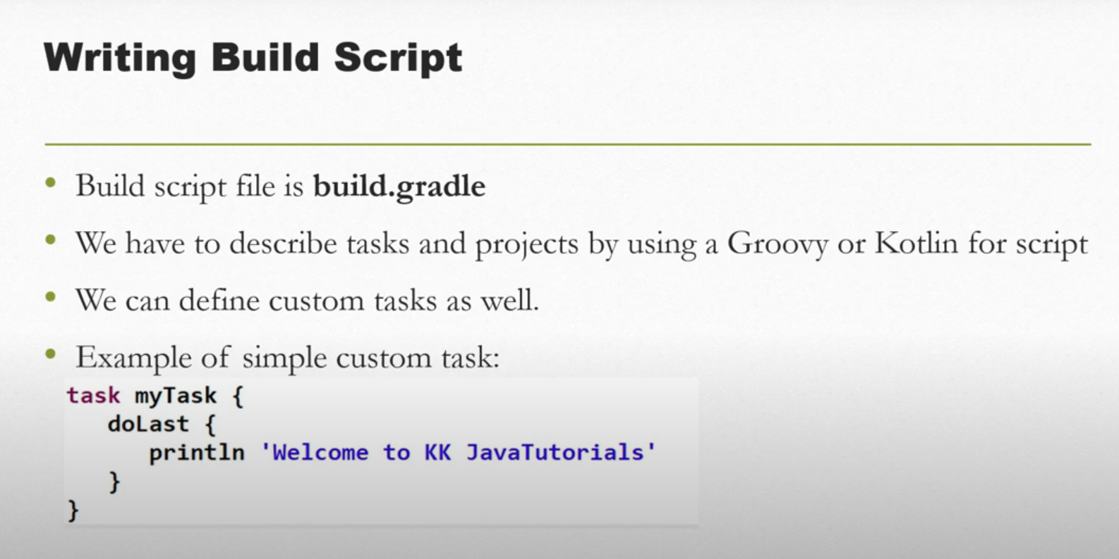

The build.gradle file has the below three sections defined in it

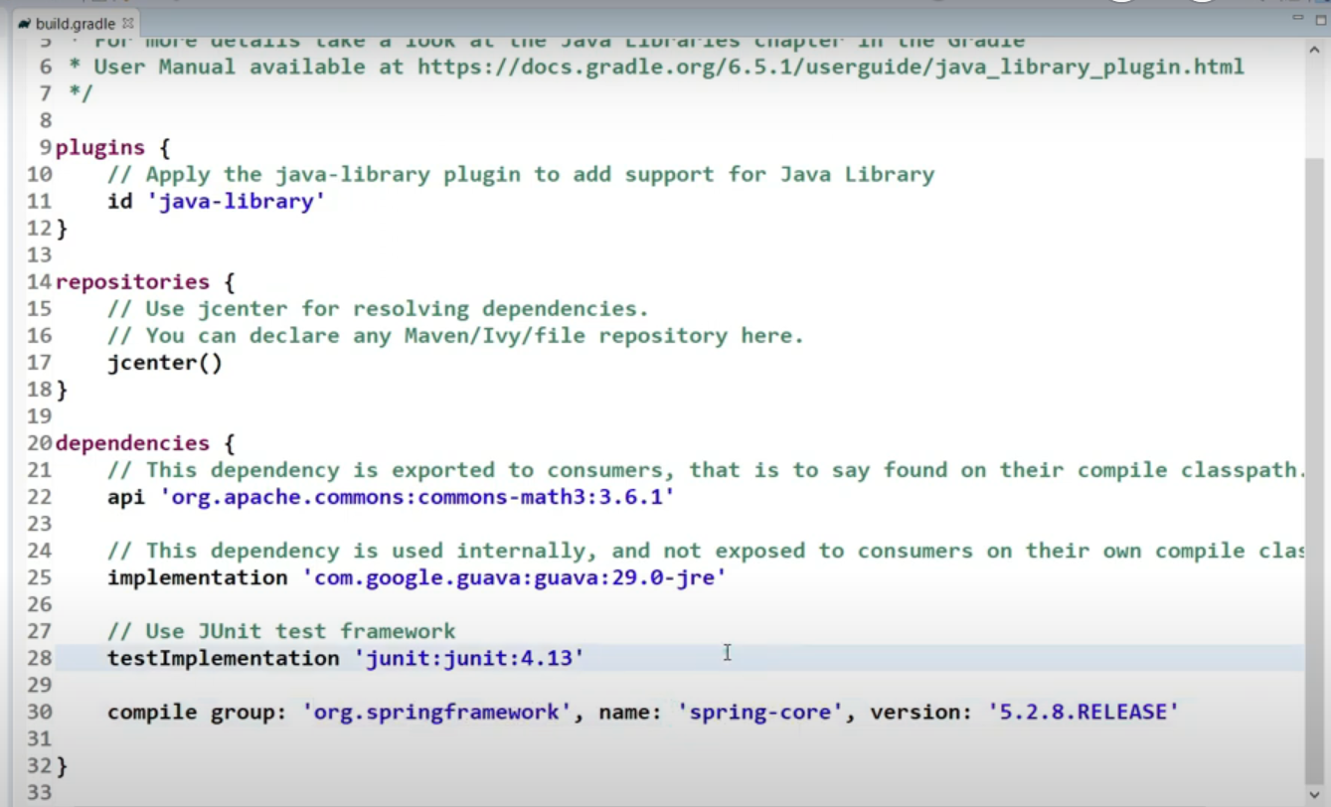

We can see the grdale tasks by going on cmd and typing gradle tasks

**STEPS**

Wite a task do a gradle refresh project and see your task in the cmd

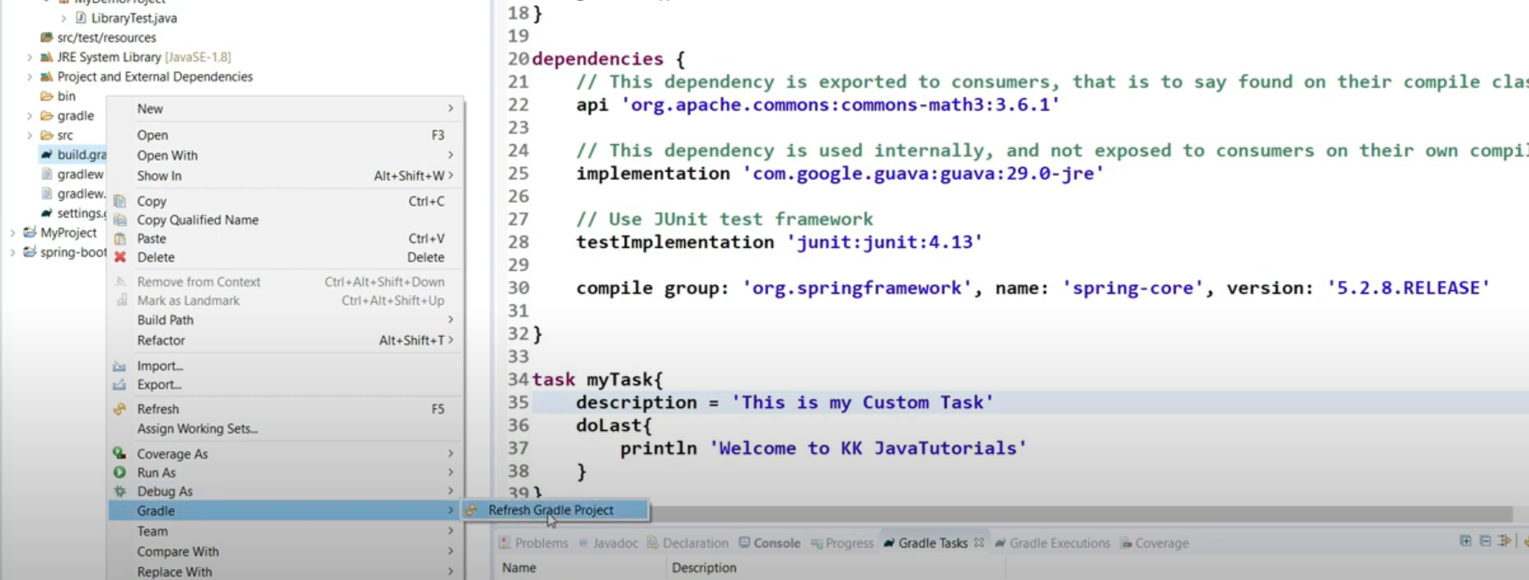

Running the task

**Gradke -q Mytask**

**GRADLE PROJECTS AND TASKS**

Everything In gradle is eithera project or a task



